Joel Atkinson
May 14, 2026
CSD440 Server-Side Scripting
Assignment 10.2
JoelJSON.php code:
<!-- Joel Atkinson, May 14, 2026. CSD440 Server-Side Scripting Assignment 10.2
The purpose of this program is to provide an HTML form that collects nine
different fields of fan-profile data from the user. When the form is
submitted, the PHP CGI validates each field. If every field passes
validation, the data is encoded into JSON using json_encode and shown
inside a well-formatted output display. If any field fails validation, a
clearly formatted error display lists the problems instead.
-->
<!DOCTYPE html>
<html lang="en">
<head>
<meta charset="UTF-8">
<meta name="viewport" content="width=device-width, initial-scale=1.0">
<title>Joel's JSON Form</title>
<style>
body {
font-family: Arial, sans-serif;
margin: 0;
}
.banner {
background-color: #663399;
padding: 20px 40px;
}
h1 {
color: #DAA520;
margin: 0;
text-align: center;
}
h2 {
color: #663399;
text-align: center;
margin-top: 30px;
}
.divider {
border: none;
border-top: 3px solid #DAA520;
margin: 0;
}
.content {
margin: 30px auto;
max-width: 700px;
padding: 0 40px;
}
.nav-bar {
text-align: center;
margin: 20px 0;
}
.nav-bar a {
color: #663399;
text-decoration: none;
font-weight: bold;
margin: 0 10px;
}
.nav-bar a:hover {
text-decoration: underline;
}
label {
display: block;
margin-top: 15px;
font-weight: bold;
color: #333;
}
input[type="text"],
input[type="email"],
input[type="tel"],
input[type="number"],
input[type="date"],
select,
textarea {
width: 100%;
padding: 8px;
margin-top: 5px;
border: 1px solid #666;
border-radius: 4px;
box-sizing: border-box;
font-family: Arial, sans-serif;
}
textarea {
resize: vertical;
min-height: 80px;
}
.submit-btn {
margin-top: 25px;
padding: 10px 30px;
background-color: #663399;
color: #DAA520;
border: none;
border-radius: 4px;
font-size: 16px;
cursor: pointer;
display: block;
width: 100%;
}
.submit-btn:hover {
background-color: #7a42b0;
}
.submit-btn.link {
text-align: center;
text-decoration: none;
display: block;
}
.error-box {
background-color: #ffe0e0;
border: 2px solid #cc0000;
color: #cc0000;
padding: 15px 20px;
border-radius: 4px;
margin: 20px 0;
}
.error-box ul {
margin: 10px 0 0 0;
padding-left: 20px;
}
.success-box {
background-color: #e0ffe0;
border: 2px solid #008800;
color: #008800;
padding: 15px 20px;
border-radius: 4px;
margin: 20px 0;
text-align: center;
font-weight: bold;
}
.json-box {
background-color: #f4f0fa;
border: 2px solid #663399;
border-radius: 4px;
padding: 15px 20px;
margin: 20px 0;
color: #222;
font-family: "Courier New", Courier, monospace;
font-size: 14px;
white-space: pre-wrap;
word-break: break-word;
}
.info {
text-align: center;
color: black;
margin: 20px 40px 40px;
line-height: 1.8;
}
</style>
</head>
<body>
<div class="banner">
<h1>Joel's JSON Form</h1>
</div>
<hr class="divider">
<div class="content">
<?php
// Decide whether to process a submission or display an empty form.
if ($_SERVER["REQUEST_METHOD"] === "POST") {
// Pull each field from the POST array, trimming whitespace and
// defaulting to an empty string when a field was not submitted.
$firstName = trim($_POST["first_name"] ?? "");
$lastName = trim($_POST["last_name"] ?? "");
$email = trim($_POST["email"] ?? "");
$phone = trim($_POST["phone"] ?? "");
$dob = trim($_POST["dob"] ?? "");
$sport = trim($_POST["sport"] ?? "");
$team = trim($_POST["team"] ?? "");
$newsletter = trim($_POST["newsletter"] ?? "");
$comments = trim($_POST["comments"] ?? "");
// Collect any validation errors into a single list.
$errors = array();
if (empty($firstName)) {
$errors[] = "First Name is required.";
} elseif (strlen($firstName) > 50) {
$errors[] = "First Name must be 50 characters or fewer.";
}
if (empty($lastName)) {
$errors[] = "Last Name is required.";
} elseif (strlen($lastName) > 50) {
$errors[] = "Last Name must be 50 characters or fewer.";
}
if (empty($email)) {
$errors[] = "Email is required.";
} elseif (!filter_var($email, FILTER_VALIDATE_EMAIL)) {
$errors[] = "Email must be a valid email address.";
}
if (empty($phone)) {
$errors[] = "Phone is required.";
} elseif (!preg_match('/^[0-9 ()+\-]{7,20}$/', $phone)) {
$errors[] = "Phone must be 7-20 characters of digits, spaces, +, -, or ().";
}
if (empty($dob)) {
$errors[] = "Date of Birth is required.";
} elseif (!preg_match('/^\d{4}-\d{2}-\d{2}$/', $dob)) {
$errors[] = "Date of Birth must be in YYYY-MM-DD format.";
}
$validSports = array("Baseball", "Basketball", "Football", "Hockey", "Soccer");
if (!in_array($sport, $validSports, true)) {
$errors[] = "Favorite Sport must be selected from the list.";
}
if (empty($team)) {
$errors[] = "Favorite Team is required.";
} elseif (strlen($team) > 75) {
$errors[] = "Favorite Team must be 75 characters or fewer.";
}
if ($newsletter !== "Yes" && $newsletter !== "No") {
$errors[] = "Newsletter choice must be Yes or No.";
}
if (empty($comments)) {
$errors[] = "Comments are required.";
} elseif (strlen($comments) > 500) {
$errors[] = "Comments must be 500 characters or fewer.";
}
// If anything failed validation, show the error display and stop.
if (!empty($errors)) {
echo '<div class="error-box">';
echo '<strong>Your submission could not be encoded as JSON because of the following problems:</strong>';
echo '<ul>';
foreach ($errors as $error) {
echo '<li>' . htmlspecialchars($error) . '</li>';
}
echo '</ul>';
echo '</div>';
echo '<a href="JoelJSON.php" class="submit-btn link">Go Back</a>';
} else {
// Build an associative array of the validated values.
$formData = array(
"first_name" => $firstName,
"last_name" => $lastName,
"email" => $email,
"phone" => $phone,
"date_of_birth" => $dob,
"favorite_sport" => $sport,
"favorite_team" => $team,
"newsletter_signup" => $newsletter,
"comments" => $comments
);
// Encode the array into JSON. JSON_PRETTY_PRINT gives readable
// indentation, and JSON_UNESCAPED_SLASHES keeps the output clean.
$jsonOutput = json_encode($formData, JSON_PRETTY_PRINT | JSON_UNESCAPED_SLASHES);
// json_encode returns false if it cannot encode the data - check
// explicitly and show an error display if that happens.
if ($jsonOutput === false) {
echo '<div class="error-box">';
echo '<strong>JSON encoding failed:</strong> '
. htmlspecialchars(json_last_error_msg());
echo '</div>';
echo '<a href="JoelJSON.php" class="submit-btn link">Go Back</a>';
} else {
echo '<div class="success-box">Form data was successfully encoded as JSON.</div>';
echo '<h2>JSON Output</h2>';
echo '<div class="json-box">' . htmlspecialchars($jsonOutput) . '</div>';
echo '<a href="JoelJSON.php" class="submit-btn link">Submit Another</a>';
}
}
} else {
// No POST submission yet - show the empty form.
?>
<h2>Enter Your Fan Profile</h2>
<form method="POST" action="JoelJSON.php">
<!-- Field 1: First Name (text) -->
<label for="first_name">First Name:</label>
<input type="text" id="first_name" name="first_name"
maxlength="50" placeholder="First Name">
<!-- Field 2: Last Name (text) -->
<label for="last_name">Last Name:</label>
<input type="text" id="last_name" name="last_name"
maxlength="50" placeholder="Last Name">
<!-- Field 3: Email (email) -->
<label for="email">Email:</label>
<input type="email" id="email" name="email"
maxlength="100" placeholder="Enter Your Email">
<!-- Field 4: Phone (tel) -->
<label for="phone">Phone:</label>
<input type="tel" id="phone" name="phone"
maxlength="20" placeholder="e.g. (555) 123-4567">
<!-- Field 5: Date of Birth (date) -->
<label for="dob">Date of Birth:</label>
<input type="date" id="dob" name="dob">
<!-- Field 6: Favorite Sport (select dropdown) -->
<label for="sport">Favorite Sport:</label>
<select id="sport" name="sport">
<option value="">-- Select a Sport --</option>
<option value="Baseball">Baseball</option>
<option value="Basketball">Basketball</option>
<option value="Football">Football</option>
<option value="Hockey">Hockey</option>
<option value="Soccer">Soccer</option>
</select>
<!-- Field 7: Favorite Team (text) -->
<label for="team">Favorite Team:</label>
<input type="text" id="team" name="team"
maxlength="75" placeholder="e.g. Arizona Cardinals">
<!-- Field 8: Newsletter Signup (radio) -->
<label>Sign Up for Newsletter?</label>
<div style="margin-top: 5px;">
<input type="radio" id="newsYes" name="newsletter" value="Yes">
<label for="newsYes" style="display:inline; font-weight:normal;">Yes</label>
&nbsp;&nbsp;
<input type="radio" id="newsNo" name="newsletter" value="No">
<label for="newsNo" style="display:inline; font-weight:normal;">No</label>
</div>
<!-- Field 9: Comments (textarea) -->
<label for="comments">Comments:</label>
<textarea id="comments" name="comments" maxlength="500"
placeholder="Tell us a little about yourself..."></textarea>
<button type="submit" class="submit-btn">Submit as JSON</button>
</form>
<?php } ?>
</div>
<p class="info">
<strong>Author:</strong> Joel Atkinson<br>
<strong>Course:</strong> CSD 440 - Server-Side Scripting<br>
<strong>Assignment:</strong> 10.2 - JSON Form Page<br>
<strong>Description:</strong> This program displays an HTML form that
collects nine different fields of fan-profile data. When the form is
posted back to the same PHP CGI, each field is validated. If every
field is valid, the data is encoded with json_encode and displayed in
a pretty-printed, well-formatted output box. If any field fails
validation - or if json_encode itself fails - an error display lists
the problem so the user can correct it and resubmit.
</p>
</body>
</html>

Screenshot of output when navigating to localhost/JoelJSON.php:
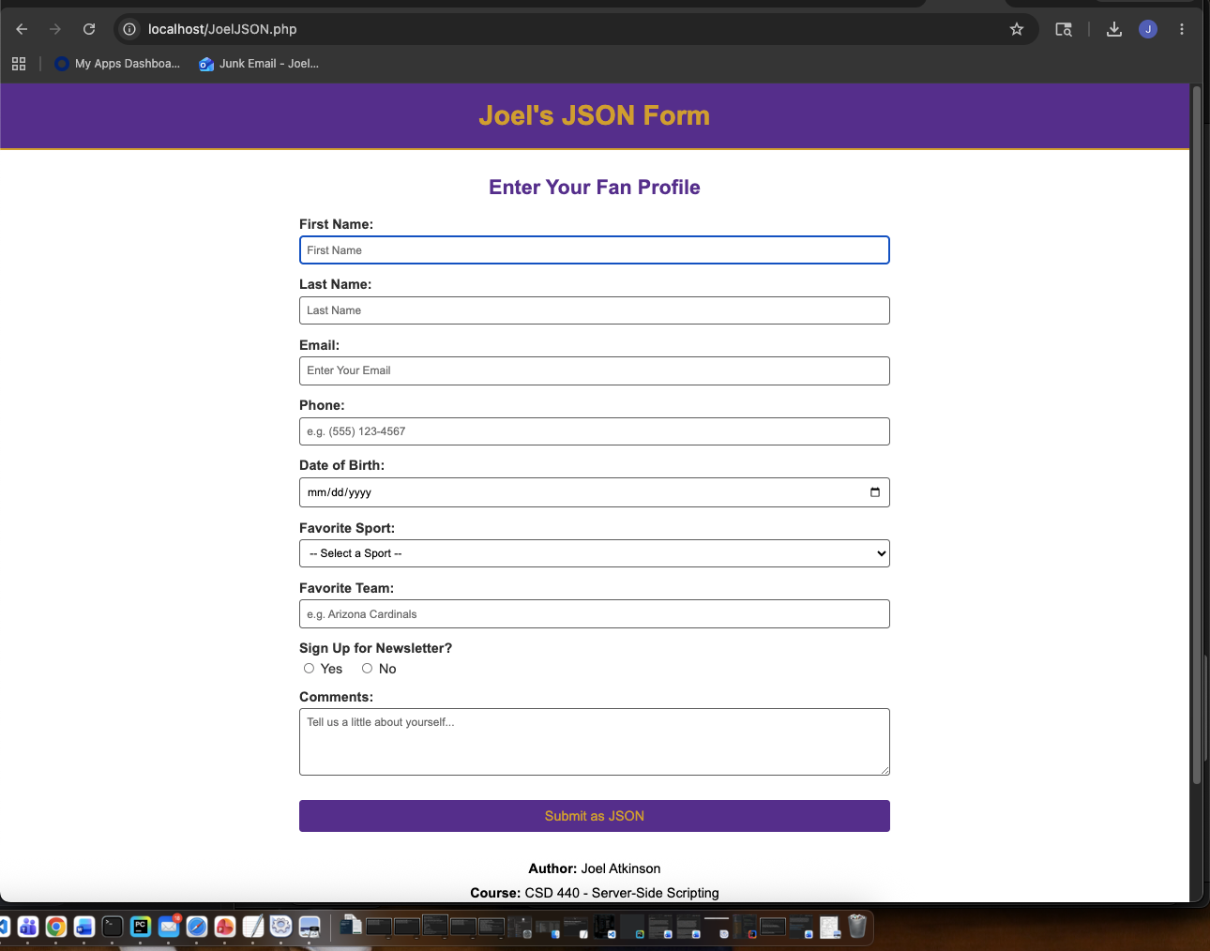
Screenshot of output after filling in form and hitting submit. Everything works as it should and displays the JSON output:
